**2. Ingress Introduction Part 2**

--- in this lesion, we are going to learn about AWS ALB ingress controller on high level. Before going to ALB ingress controller, we are going to look into AWS application load balancer.

--- let’s see what is application load balancer and what it supports…? We will see how the application load balancer is created from kubernetes manifests.

**What is application load balancer in AWS…?**

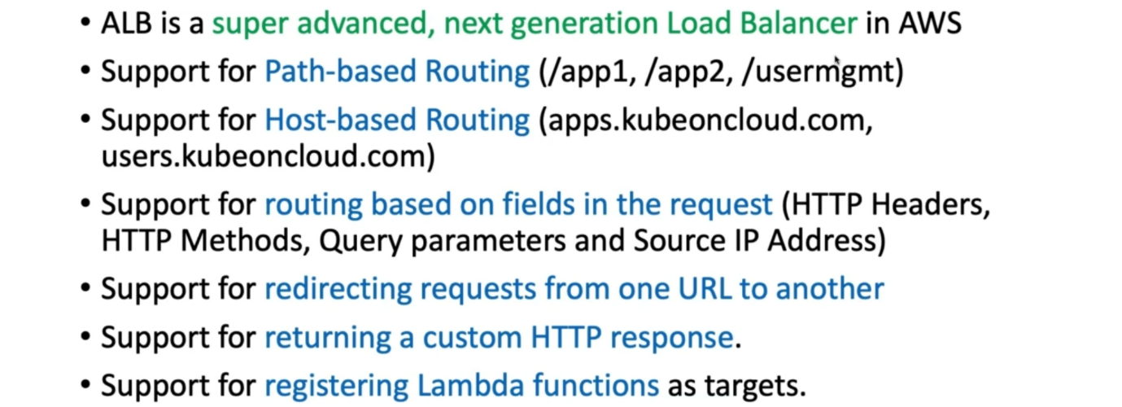

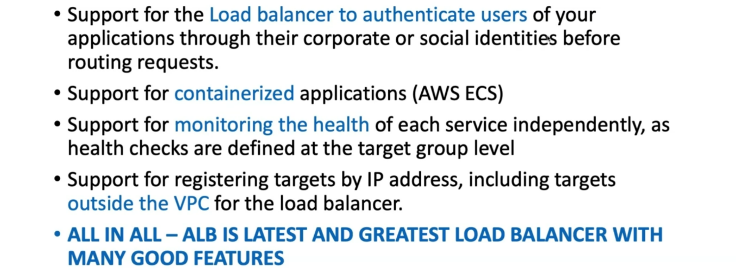

--- AWS application load balancer can be used for kubernetes ingress manifest.

**ALB ingress controller - ALBIC**

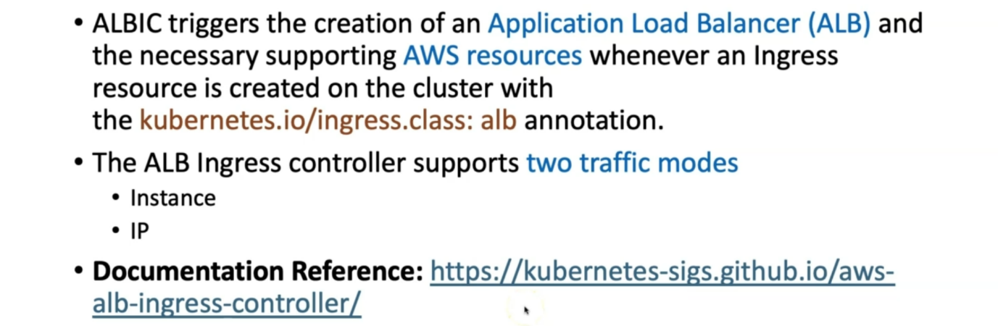

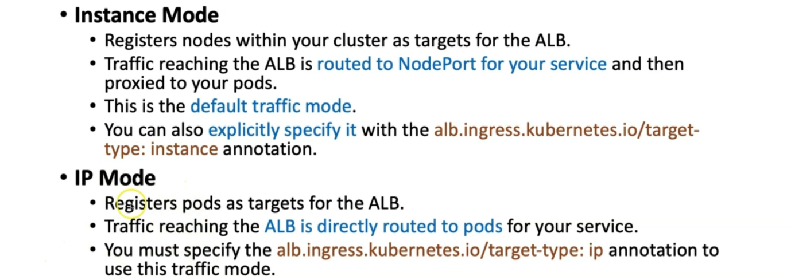

--- **note** – fargate way is serverless concept, so we cannot route the traffic to server. That is why we need to route the traffic to pods. IP mode is very useful in these scenarios.

**How ALB ingress works…?**

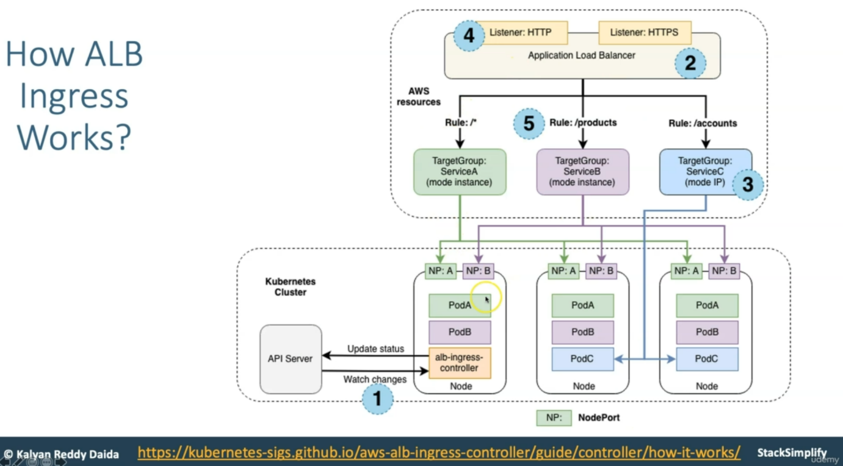

--- this is in Kubernetes cluster and these are AWS resources. The application load balancer is created for the new ingress resource in the kubernetes cluster. This application load balancer will have the version of **ELB V2**. There are 2 types of elastic load balancer resources in aws.

--- **NOTE** - Whenever you’re giving IAM permission and all those stuffs, you need to ensure the ELB v2 is added in those permissions.

--- target groups is created in AWS, each unique kubernetes service described in ingress resources. Whatever application nodeport defined in your manifests

--- whatever listeners specified for application load balancer, those listeners will create in application load balancer.

--- **note** – if you want to delete all those things then just delete the kubernetes manifest and those resources gets deleted.